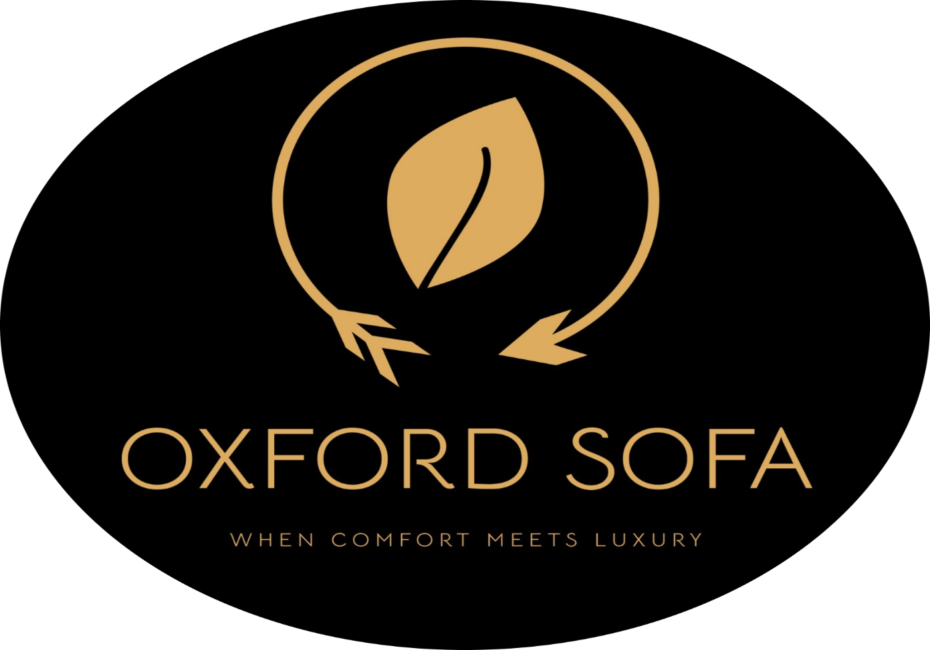

Introduction:
Welcome to Oxford Sofa, which is not only furniture but it’s a fusion of luxury, comfort, and contemporary style. Each sofa we make is designed with superior materials, beautiful stitching, and sleek appearances to perfectly place in your home. Our mission is to provide you with long-lasting timeless comfort to last for decades, and every moment of rest a treasured one. Oxford Sofa makes your home a haven of splendor, elegance, and genuine comfort.

History and Revolution of Sofas

The sofa revolution demonstrates how style and comfort have transformed over time. From basic wooden benches to rich, soft, and fashionable styles, sofas have become synonymous with comfort and elegance. Contemporary sofas now incorporate technology with comfort—ranging from recliners and intelligent fabrics to sustainable materials. This transformation indicates how lifestyle, innovation, and design have combined to redefine the concept of comfort in each dwelling.

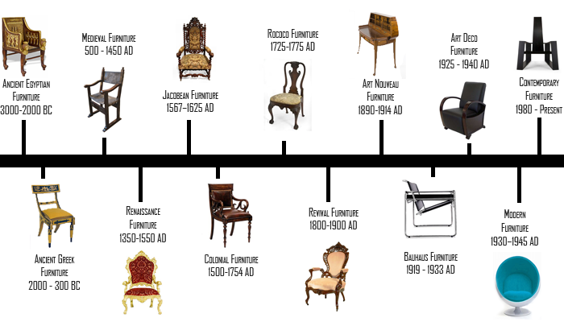

Our Luxury Brands

Poltrona Frau:
Poltrona Frau is renowned for luxury Italian leather furniture, handcrafted excellence, and timeless design, using premium Pelle Frau® leather and 21-step tanning. Famous for iconic pieces like the Chester armchair, it also creates bespoke interiors for luxury cars, yachts, and aviation, and public spaces like the European Parliament

Ligne Roset:
Ligne Roset is famous for its innovative contemporary furniture, especially the iconic Togo sofa . A sculptural, low-profile design by Michel Ducaroy known for its wrinkled leather look and comfort and for collaborating with leading designers to create bold, artistic pieces showcased at major design events like Milan Design Week.

Flexform:

Flexform is an Italian luxury furniture brand founded in 1959 by the Galimberti brothers in Meda, within the renowned furniture district of Brianza. Specializing in high-end sofas, armchairs, and living room furniture, Flexform combines "Made in Italy" craftsmanship with timeless design, focusing on comfort, quality, and understated elegance. The brand is celebrated for long-standing collaborations with top designers, especially architect Antonio Citterio, who has shaped its collection for over four decades. Iconic pieces like the Groundpiece and Soft Dream sofas reflect a philosophy of relaxed, functional luxury, using premium materials such as goose-down cushions and refined fabrics. All production remains entirely in Italy, reinforcing its commitment to heritage and excellence.

Natuzzi Italia:
Natuzzi Italia is the premium brand of the Natuzzi Group, founded in 1959 by Pasquale Natuzzi in Santeramo in Colle, Italy. Renowned for its luxury leather upholstery and modern Italian design, it creates harmonious living spaces with high-end sofas, armchairs, and full home collections. All products are designed by international designers and crafted in Italian factories, emphasizing comfort, craftsmanship, and timeless style. A global leader in leather furniture, Natuzzi Italia is part of the world’s most recognized Italian furniture brand, traded on the NYSE (NTZ), with a presence in over 120 countries.

- Group member and their roles

Member names | Roles | Responsibilities
Junaid | Poltrona frau page ,Ligne Roset page , Flexform, Natuzzi Italia page and Home page | Footer of every page and review every page
Aaliyaan | About page ,ppt and word documentation | About page and every page review
Wasil | Brand page ,compare page , login and signup page | Complete requirements and advance topic ,Navbar
Misem | Contact page, Booking page | Form designer

